The Activ84Health Explorer:
Stimulating physical and cognitive health in elderly users

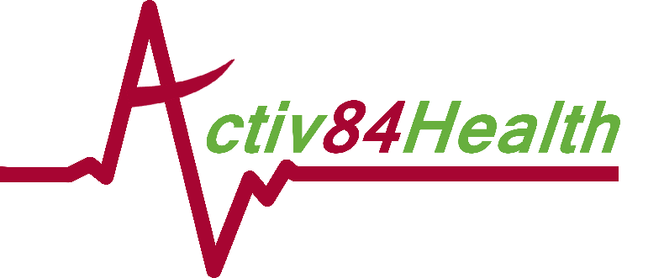

Executive Summary
The Activ84Health Explorer is a platform that allows users to freely explore known and new areas while being physically active, from within the safety and comfort of an indoor setting.
The Activ84Health Explorer uses Google Streetview images to allow the user to virtually go outside again and (re)opens a window to the world for the users. The platform stimulates reminiscence, challenges the user to remain physically active and train their memory, and promotes exploration. The Activ84Health Explorer relies on cloud-based software, and requires a tablet for navigation (through the touch-screen functionality). Each user has an individual profile, which allows the platform to take into account personal physical and cognitive abilities. The concept behind the Activ84Health Explorer was developed by Jan Smolders, Director of Nursing Home Witte Meren in Mol (Belgium), specifically to allow elderly users to virtually go outside again from within the safety, security and comfort of the physiotherapy room, and relive the memories they have about the areas they used to live, work, be active,… in. Each aspect of the Activ84Health Explorer has been thoroughly tested through user-centred design, in close cooperation with the nursing home inhabitants.
The Activ84Health Explorer is built around two core values:
- User autonomy: Our user typically is an individual that faces a physical, cognitive or logistic restriction. Although many of these individuals would like to remain physically active, they can no longer go outside independently anymore to go out for a walk or a bike ride. Therefore, they are confined to remain within the safety and security of the four walls of a (nursing) home. The Activ84Health Explorer offers user autonomy based on four levels:
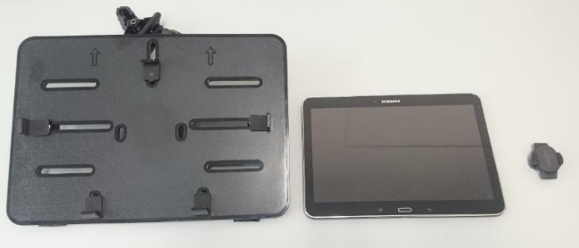
  - Choice of activity: The Activ84Health Explorer has a very simple and flexible hardware setup (tablet holder - touchscreen tablet - cadence sensor, see picture) which allows it to connect to virtually every fitness device available. While most users install the Activ84Health Explorer on a stationary bike for indoor cycling, the system can just as well be used for a treadmill, cross trainer, rowing machine,… This flexibility hence offers the user the freedom to engage in the activity of their own choice;
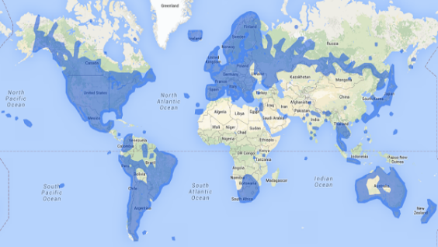
  - Choice of location: As the Activ84Health Explorer uses Google Streetview images, a whole world of possibilities opens up for the user. As long as Google has 360° pictures available, the Activ84Health Explorer can take you outside to visit known locations and explore new experiences. Currently, most of Europe, North and South America, and Australia and New Zealand are available and the country portfolio is continuously expanding. Although experience has already taught us that most users are primarily interested in their own home town, neighbourhood and street where they used to live, the possibilities to explore are virtually endless;
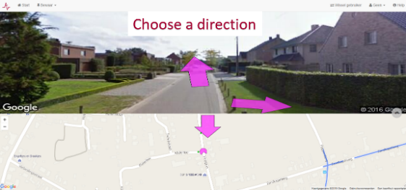
  - Choice of route: Once an starting location is selected, the user has full freedom to navigate and choose the route he or she wants. At each intersection or route choice, arrows on the tablet screen display the different possibilities. By simply tapping on the arrow of choice, the user can define his/her own route. Again, this option makes the possibilities to navigate almost endless, and implies that the user is not limited to predefined routes or a limited number of selected options.
  - Fit to each user’s abilities: In order to ascertain that individuals with all physical and cognitive abilities can enjoy the possibilities of the Activ84Health Explorer, it is also possible to choose for automatic progression (the so-called ‘taxi button’ which offers a decoupling of the aspect of physical activity for individuals with physical restrictions, e.g. in a wheelchair). For users with cognitive impairment, routes can be defined which ommits the need to make navigational choices at each intersection and simply offers an enjoyable route through a neighbourhood of choice;
- Stimulation of reminiscence: All aspects of the user autonomy are developed in such a way that it offers the user to explore known and new locations, in search of memories, stories to tell, and new sights to wonder about. Experience has shown that users not only spontaneously share individual memories related to specific streets or houses, but that the Activ84Health Explorer can also be used in a group context to stimulate the social cohesion and collective memory of a larger group of individuals.
The possibilities of the Activ84Health Explorer to be fully fitted to suit each individual user’s needs on how to engage in physical activity, to do this in a meaningful environment, and to share the stories related to these locations with others is Activ84Health’s Unique Selling Proposition.
The Activ84Health Explorer currently is being purchased by nursing homes, hospitals, rehabilitation centres and home care organisations for €2.450 (excluding VAT). This one-time product fee includes all the hardware, the training , installation and customer support, and a one-year software license. From the second year onwards, an annual license fee of €500 is charged. This price setting was the result of a three way market consultation process:
- Assessing willingness to pay and expected price with potential customers (through interviews);
- Revenue versus cost assessment in our financial plan;
- Checking the cost of our potential competitors.
Currently, the Activ84Health Explorer is being offered to our customers through direct sales in Belgium and the Netherlands. In the next year, Activ84Health will gradually develop a network of national distributors to shift from direct to indirect sales across Europe and beyond. Distributor contracts with parties in the Netherlands and Flanders are already being set up. The continued shift from direct to distributor-based sales is one of Activ84Health’s major upcoming milestones.
From a health perspective, The Explorer already allows the collection of individual data on levels of physical activity, dedicated indicators such as duration of a work-out, cadence speed and route choice. One of the additional future milestones for Activ84Health is to continue the development of our MVP towards a more integrative health hub, in which we will be able to collect additional data on the physical health conditions of our users through e.g. wearable sensors (monitoring of daily activity patterns when not exercising on the Activ84Health Explorer) and cognitive functions (through data on route finding and navigational choices). Additionally, further development of serious games and exergames to increase user experience and motivation are high on our development agenda.
As the process of user-centred design and end-user engagement is a time-consuming and resource- intensive activity, the AAL Challenge prize would first and foremost be used to improve the quality of the user experience and to define the priority of additional features to be developed. Additionally, the prize money (and the marketing exposure associated with it) will also help us to increase our international distributor network and scale up our technology to a European level.

Innovation in internet connected devices
“How can I keep my inhabitants physically active in a fun, safe and motivating environment?”… That was the question Jan Smolders, Director of Nursing Home Witte Meren in Mol (Belgium) was struggling with. Like all nursing homes, Witte Meren is equipped with a physiotherapy room where different fitness devices are available, and where inhabitants come to exercise.
As for all individuals, irrespective of age, or physical and cognitive abilities, remaining physically active has an important positive effect on the general physical and mental health. Yet this poses significant challenges in a nursing home setting, where inhabitants tend to live within the four walls of the nursing home because physical, cognitive or logistic restrictions limits their opportunities to go outside to exercise.
And how motivating and fun is looking at a blind wall, or through a window, for the duration of your exercise session…
This was the issue that Activ84Health wanted to focus on with the development of the Activ84Health Explorer. It wasn’t a technology-driven question. It was an issue that was recognized and defined by the elderly care sector itself.
Together with his brother Roel, and Wannes and Jesse, two IT-specialists from the University of Louvain, Jan started Activ84Health to develop the technology needed to keep his nursing home inhabitants physically active in a fun, motivating and safe environment. From his more than 20 years of experience, Jan knew that the technology would need to adhere to three essential requirements:
- It needed to be a flexible solution so it would fit the variable physical and cognitive capacities of the end-users;
- The solution had to stimulate autonomy, and pose as few boundaries as possible for the user;
- As memories and stories are the greatest treasure that elderly individuals have, the solution needed to stimulate reminiscence as much as possible.
After more than two years of intense prototyping, user-centred design, testing of all different features of the technology at Nursing Home Witte Meren and some other institutions, the Activ84Health Explorer was born and put on the market. The Activ84Health Explorer was the result of intense cooperation between health technology- and IT-experts, occupational and physical therapists, and the elderly end-users.
Briefly, the Activ84Health Explorer consists of two complementary components:
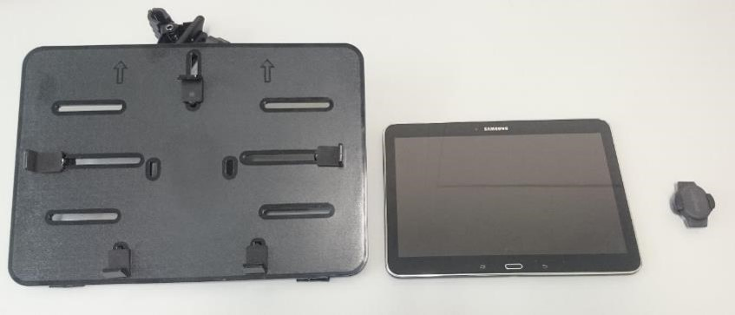
  - Hardware component: The Activ84Health Explorer has a very simple and flexible hardware setup (touchscreen tablet - tablet holder - cadence sensor, see picture) which allows it to connect to virtually every fitness device available. This hardware is purchased from other manufacturers (commercially available off-the-shelf). The tablet holder (most left) is simply used to attach the touchscreen tablet to any fitness device available in the physiotherapy room. The tablet is the central operating system of the Activ84Health Explorer, and is used for connection to the cloud-based software and for navigation (see further). The cadence sensor is essential to make the connection between the physical activity and the progression in the virtual environment. If the user moves quickly, he will progress quickly through a street; if he moves slowly, progression slow down. If the user stops moving, the Activ84Health Explorer also halts and there is time to look around and explore the scenery. Hence, the user is offered an interactive experience in which physical activity and virtual experience are integrated;
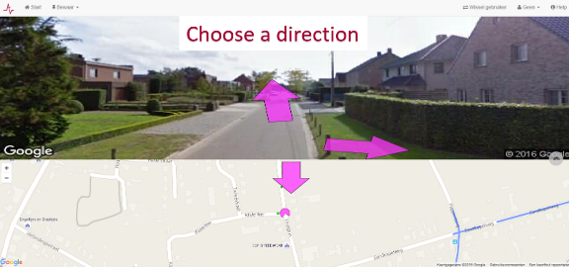
  - Software component: The core of the Activ84Health Explorer is the software. The Activ84Health Explorer makes use of Google Streetview images, which opens up a whole world of possibilities for the user. As long as 360° pictures are available for a location, the Activ84Health Explorer can take the user there, and provides them with the opportunity to visit known locations and explore new experiences. Coverage is almost ubiquitous in most of Europe, and also large parts of North and South America, Australia and New Zealand are available (see map). However, extensive testing and user consultation has already taught us that most users are primarily interested in their own home town, neighbourhood and street where they used to live. Through the use of Streetview images, the Activ84Health Explorer has the unique capacity to offer this opportunity to all users, and take them back to the places where their memories are located. Additionally, the software is developed in such a way to provide an intuitive and very simple means of navigation. Points of interest and user-defined routes can be stored in individual profiles, and navigation through the world is done through arrows that display route options at each intersection (see picture). The user simply has to tap on the arrow of the desired direction, and can continue his or her journey along the path chosen by the user. As the software is stored in a cloud-environment, users do not need to go through installation or update procedures.
The combination of these two components makes for a very flexible, easily transportable, simple yet intuitive product that offers a fun, motivating and safe environment for the end-user to virtually go outside again to the locations where they used to live, work, or go on holidays. Navigating through the streets, they can go chase their memories, and engage in story telling about their past experiences associated to specific locations.
The possibilities of the Activ84Health Explorer to be fully fitted to suit each individual user’s needs on how to engage in physical activity, to do this in a meaningful environment, and to share the stories related to these locations with others is Activ84Health’s Unique Selling Proposition.
Although there are some other manufacturers that develop image-based solutions to keep elderly users entertained and motivated to be physically active in a virtual environment (e.g. fietslabyrinth.nl, Silverfit,…), they typically only offer solutions that allow activity in very limited, predefined environments (e.g. only major cities), and are not flexible in terms of choice of activity. Also some fitness device manufacturers have developed image-based products, yet they don’t offer freedom to navigate, typically only offer high-profile training experiences (e.g. climbing Mont Ventoux) and have no clue about elderly user’s expectations. We believe that the Activ84Health Explorer offers a unique combination of features that makes our product superior to others available in the market:
- User freedom to choose the type of exercise;
- Full autonomy to choose where to go and visit and explore known and new locations, only limited by the availability of Streetview images and the user’s imagination;
- A choice between the opportunity to freely navigate through the world or to explore predefined routes;
- A “taxi-button” (which automates progression) and the ability to predefine routes (which automates navigation) ascertains that also users with physical and/or cognitive restrictions can maximize the value of their experience within the range of their abilities.
Currently, the Activ84Health Explorer’ database collects individual data on the type, duration and frequency of physical activity, and looks at dedicated indicators such as cadence speed and route choice, yet we are looking to expand this to a much larger set of health-related endpoints. One of the future milestones for Activ84Health is to continue the development of the Activ84Health Explorer towards a more integrative health hub, in which we will be able to collect additional data on the physical health conditions of our users through e.g. wearable sensors (monitoring of daily activity patterns when not exercising on the Activ84Health Explorer) and cognitive functions (through data on route finding and navigational choices). Additionally, further development of serious games and exergames to increase user experience and motivation are high on our development agenda.

Quality and Usability
For more than one year now, each aspect of the Activ84Health Explorer has been thoroughly tested in the setting of Nursing Home Witte Meren in Mol, where Activ84Health has a permanent setup. We have focused on user-centred design in each step of the process, starting from the definition of the architecture and basic functionalities (which were defined from an identified need, not through technology push) until larger scale, long term tests at other nursing homes.
As we currently still are focusing on direct sales at nursing homes, rehabilitation centres and home care organisations, we invest a lot of time and effort in customer relationships. This allows us to get additional user information and feedback from more than a dozen platforms that operate daily throughout Flanders. Despite the fact that we as developers have a lot of great ideas on the ways forward, and to develop new features and applications, it is our customers that drive our Activ84Health development agenda. They know better than anyone what additional features will increase the value of our MVP, and what the expectations and desires of the end-user are.
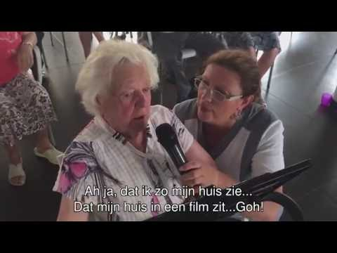
From our extensive end-user consultation and observation, we know that their primary value lies in the fact that they can virtually go outside again, visit the locations where they used to live or work, and share the stories that are associated with these locations. And if there is one thing that elderly individuals have in abundancy, it is stories, memories and the willingness to share these. From observation, we know that the Activ84Health Explorer has a tremendous impact on the stimulation of reminiscence. The added short video perfectly illustrates how the Activ84Health Explorer creates added physical and emotional value for the end-user (make sure to switch on subtitles).
We have put a lot of energy and attention to the fact that the Activ84Health Explorer should be as flexible and versatile as possible in order to take into account the highly variable physical and cognitive capacities of the end-user. The entire software platform can be operated by two clicks, and as the software is fully cloud-based, no installation or software updates are needed. All software and user data are safely stored in the cloud. As such, the platform can very easily be operated by people with different levels of digital literacy. The addition of the “taxi-button” and the predefined routes option (see earlier) also allows individuals with physical and/or cognitive limitations to maximize their own personal user experience.
As far as we have observed or heard from our customers, there are no explicit safety risks associated to the use of the Activ84Health Explorer, other than those associated with the normal operation of fitness devices such as a stationary bike, cross trainer or treadmill. In our discussions with end-users and care organisations, we regularly get questions about the possibility to link the Activ84Health Explorer to an Oculus Rift (or other type of Virtual-Reality goggles), or to make a moving steering wheel to offer other navigational options than the touchscreen arrows. From a safety point of view, we choose not to develop these features to limit the falls risk, but may exploit their value for other target populations (e.g. rehabilitation) in the future. The only potential safety point we have observed so far is that users become so engaged in exploration, that they may strain themselves and exercise for too long. At one point, we observed one elderly lady of an age over 85 to bike for 41 minutes through the Flemish town of Turnhout, constantly talking about where she used to live and work. She was so involved in her story telling, that we had to stop her after 41 minutes…

Market Potential
Currently (August 2016), Activ84Health has sold a dozen of its Explorer minimum viable products (MVP) since it came on the market end of March 2016. Customers include nursing homes, hospitals and family care organisations in both Belgium and the Netherlands. Many more sales visits have been made and are scheduled in the autumn of 2016, and sales are ahead of the prognosis in our business plan. At the moment, we still focus on direct sales (visits made by Roel Smolders, CEO) because we want to maintain a close relationship with our customers and end-users. At this stage of our development, end-user consultation remains essential to understand which comments and ideas our customers have to further develop the Activ84Health Explorer from MVP to premium product. Therefore, periodic visits and contacts with our customers are scheduled to further identify opportunities and become aware of potential barriers at the earliest possible stage.
Because of the cloud-based nature of our solution, our technology is perfectly suited for an efficient and rapid scaling to other European countries. Text (and hence need for translation) is minimal in our product, and Streetview coverage in Europe is virtually ubiquitous (apart from Germany and Austria, where no adequate Streetview coverage exists). Building a language module to allow for international expansion is one of the key technological activities in the next year.
At the same time, we are gradually building a distributor network as well. Expansion to new, large markets such as France, Italy, Spain,… has no major technical difficulties. From a sales and marketing perspective however, development of a distributor network is one of the essential milestones we want to achieve in the near future. Obviously, being selected as finalist for the AAL Smart Ageing Prize offers another major boost for our international marketing and commercialisation opportunities, and will contribute to the international breakthrough of Activ84Health.
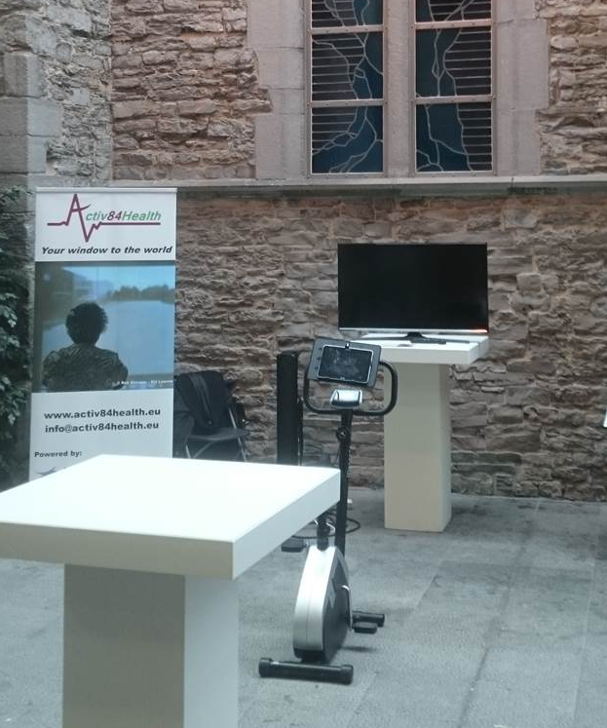
Until now, Activ84Health has been very successful in generating both media and customer attention. Several articles in Flemish newspapers have been published, a 2-minute report on the Flemish news was broadcasted (reaching more than 1 million viewers), and the recent Youtube-video (see section 3) that was posted on Facebook reached more than 300.000 views. We have clearly experienced the value of media exposure, and will continue to attract media attention to improve brand recognition across Europe.
At the same time, we have been very active in demonstrating our solution at conferences and exhibitions, as we believe that the best way to understand the value and functionalities of the Activ84Health Explorer is to experience them. The picture on the right shows our typical display at a conference (stationary bike - Activ84Health Explorer – television screen). While our setup is very simple, we usually welcome dozens of interested customers (occupational therapists, directors of health organisations, nurses,…) interested to try out the Activ84Health Explorer and try out its functionalities.
Apart from our revenue stream that we have been able to generate over the last five months, we have also secured an investment from a number of business partners and a business angel. On top of that, we have been working closely with a number of business and other partners, including incubators (StartIt@ KBC, Netwerk Ondernemen), major industrial partners (including e.g Sodexo) and others (Microsoft Innovation Center, Voka Health Community, Flanders Investment and Trade). Finally, we recently secured a grant from the Flemish Government to investigate the added value of the Activ84Health Explorer for rehabilitation purposes, and were asked to participate in different consortia submitting a proposal for the 2016 AAL-call on Dementia.

Impact
In order to assess the impact of the Activ84Health Explorer on the quality of life of older adults, the following indicators can be applied:
- Verbal confirmation of fun and motivation: Although it may not be a strictly scientifically sound approach, there is great value in the elderly user explicitly telling us that they enjoy exercising on the Activ84Health Explorer;
- Increased physical activity: A highly quantitative indicator that reflects how often and/or how long elderly users engage in physical activity in comparison with the absence of the Activ84Health Explorer. Increased physical activity can easily be interpreted as a confirmation of joy and motivation;
- Increased number of unique users: In nursing homes, service flats, community centers,… an increased number of unique users engaging in physical activity per time period through the Activ84Health Explorer is an easily quantifiable indicator;
- Story telling: One of the unique features of the Activ84Health Explorer is that it takes users to the places where he or she used to live, work,… in search of lost memories and stories. If a user engages in reminiscence and storytelling, the Activ84Health is achieving its unique capacities;
- Increased quality of life: Although this indicator is very difficult to quantify or even qualitatively score, we have repeatedly witnessed elderly users brought to tears when going back to meaningful places from their past. For example, the Youtube video in Section 3 captures a glimpse of the emotions generated by the sight of her old house and the stories related to it.
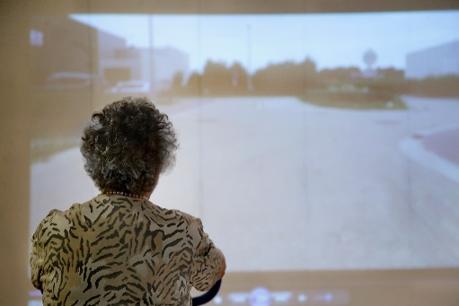
As Activ84Health stores all user activities in the backside database, it is relatively straightforward to quantify some of these indicators. For example, following a week-long demonstration setup at a nursing home within the context of the Tour of Flanders cycling race, the number of elderly users of the physiotherapy room increased from 6-7 users/week to 45 unique users in 5 days. In total, these users rode 275 km in 5 days.
At the same time, emotional value and quality of life are very difficult to quantify, which is one of the difficulties Activ84Health faces to objectively demonstrate the added value of our solution. We are currently looking at some options to set up more organised studies with research partners to (semi-) quantitatively measure this impact.
At the moment, no real health-related data are being connected as such through the Activ84Health Explorer, although it is our clear intention to further develop the MVP in that direction. As each user has a unique user profile (in which all starting points or routes of interest are stored), and all data are stored in a log-in and password protected cloud environment, there are only very limited risks regarding privacy or ethical issues. As we put a lot of care to ascertain that the Activ84Health Explorer can be operated with varying physical and cognitive capacities, the risk of stigmatization are minimal.

Prototype
There currently already is a MVP that has been purchased by a dozen of customers in Belgium and the Netherlands. Hence, the Activ84Health Explorer has long passed the point of prototype. The figure below shows the future improvements and developments we would like to implement to allow the Activ84Health to evolve from MVP to Premium Product.
However, at the same time, it should be stressed that we are convinced that the priorities of new features to be developed and additional target populations to be addressed will be defined by our customers and end-users rather than by ourselves. From that perspective, this figure should only be seen as indicative.
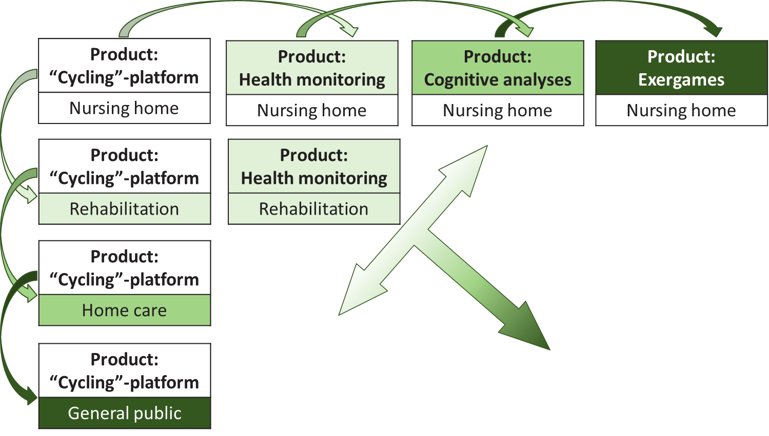
What is essential to keep in mind from a “future developments perspective”, is that:
In order to assess the impact of the Activ84Health Explorer on the quality of life of older adults, the following indicators can be applied:
- We want to develop the Activ84Health Explorer from its current status of MVP to a premium product by adding additional features and functionalities that will rely on IoT-technology and data analysis;
- New markets will become available as the Activ84Health Explorer matures, and Activ84Health will develop new business models to accommodate these markets.

Contact Details

- Name contact person: Roel Smolders
- E-mail address: roel@activ84health.eu
- Phone number: +32 486 206407
- Organisation: Activ84health nv
- Post Address: Bakenstraat 15, 460 Kasterlee
- Country: Belgium
- Website / social media: www.activ84health.eu

